|  |  |
| --- | --- |
| Information and communication technologies | Abstract  This overview explores the evolution and significance of operating systems, Microsoft Office tools, LaTeX, HTML, CSS, Git, GitHub, and Google services in shaping the modern digital age. The discussion emphasizes their transformative roles and collective impact in contemporary computing.  Tafer Abderrahmane Kibboua Melina Khouatmi Boukhatem Hannah Zaidi Dina Taieb Benabbes Nesrine |

Contents

Introduction to operating systems : 2

Microsoft Word : 3

Microsoft Excel: 4

Microsoft Powerpoint: 5

Latex: 6

HTML: 7

CSS: 8

Git and Github: 9

What Are Git and Github? 9

Why Should You Learn Git and GitHub? 9

What Is The Difference Between Git and Github? 10

Common Git Commands To Know: 10

How GitHub Revolutionized Software Collaboration 11

Google services: 12

Conclusion: 14

# Introduction to operating systems :

  
Operating systems (OS) stand as indispensable software entities that play a pivotal role in overseeing computer hardware and furnishing essential services to computer programs. Their profound significance in the computing industry spans the entire history of computing, dating back to the nascent stages characterized by the limited functionality of computer-only systems. In these early days, operating systems primarily focused on rudimentary tasks, such as managing hardware resources and providing a basic interface for user interaction.

As the computing landscape advanced and diversified, the role of operating systems underwent a transformative evolution. The historical trajectory of operating systems reflects a continuous adaptation to meet the escalating demands of increasingly complex computing environments. Early operating systems were rudimentary and geared towards facilitating the execution of basic programs. However, with the proliferation of computing needs, operating systems integrated new features and functionalities to enhance their capabilities.

A comprehensive understanding of the historical development of operating systems is essential for appreciating their intricate roles in contemporary computing. Time-sharing systems, a notable advancement, have become integral in modern computing, enabling multiple users to access a computer simultaneously. This innovation has laid the foundation for collaborative computing environments, fostering shared resource utilization and efficient multitasking.

In parallel, the advent of personal computer systems marked a revolutionary shift in the computing paradigm. Operating systems tailored for personal computing, such as Microsoft Windows, macOS, and Linux distributions, have empowered individuals by providing powerful computing tools at their fingertips. These systems have not only transformed the way we work but have also redefined communication, entertainment, and information access, making computing more accessible and user-friendly. In this report we are going to see some of the most useful Microsoft windows tools.

***What is windows?***

Operating systems vary in types, and certain variants enjoy greater usage than others. Windows stands out as a widely adopted operating system. Originating as a basic graphical user interface, Windows has developed into a comprehensive operating system specifically crafted for personal computers. Beyond its user-friendly interface, Windows holds immense significance, given its capability to seamlessly run virtually any software required by users.

# Microsoft Word :

 Microsoft Word, a renownedword processing software, made its debut in 1983 and has since evolved into an indispensable and multifaceted toolcatering to a broad spectrum of document creation needs. Beyondits humble beginnings, Microsoft Word has emerged as a cornerstone in the realm of text processing, offering a sophisticated yet user-friendly interface that facilitates seamless editing, formatting, and customization of documents. Its widespread adoption can be attributed to its adaptability, accommodating tasks ranging from crafting simple letters to generating intricate and comprehensive reports. Over the years, Microsoft Word has undergone a series of transformative updates, incorporating innovative features such as real-time collaboration, seamless integration with cloud services, and an expanded array of advanced formatting options. These enhancements have elevated its status as a versatile and indispensable tool, catering not only to writers but also to students and professionals across diverse fields. The continuous evolution of Microsoft Word underscores its commitment to staying abreast of technological advancements and meeting the evolving demands of its user base, solidifying its position as a go-to platform for effective and efficient document creation in the digital age.

# Microsoft Excel:

introduced to the world in 1985, stands as a pioneering force in the landscape of data analysis and management. From its inception as a straightforward spreadsheet program, Excel has undergone a remarkable evolution, transforming into a formidable tool renowned for its proficiency in handling intricate calculations, generating insightful charts, and visualization of numerical data

Originally designed for the Apple Macintosh, Excel swiftly became a pervasive tool in offices and homes globally after expanding to the Microsoft Windows platform in 1987. Excel's evolution has been characterized by continuous updates, with Microsoft introducing new features and adapting to technological advancements to maintain its relevance and power. Milestones such as the transition to a graphical user interface, the introduction of pivot tables, and the integration of Visual Basic for Applications (VBA) programming language have marked Excel's progressive journey. Excel's utility spans various industries, including finance, accounting, marketing, and engineering. Its versatility shines through in its adeptness at handling intricate calculations, managing extensive datasets, and creating visually compelling charts and graphs. As a dynamic tool, Excel plays a pivotal role in budgeting, financial analysis, project management, and diverse applications, making it indispensable for professionals across fields.

In the contemporary digital landscape, the significance of Excel cannot be overstated. Its user-friendly interface and robust features empower users to analyze and interpret data efficiently. Businesses utilize Excel for informed decision-making, performance metric tracking, and report creation. Educational institutions integrate Excel into curricula to equip students with essential data management and analysis skills. Moreover, Excel's compatibility with other Microsoft Office applications enhances its seamless integration into broader productivity workflows.

# Microsoft Powerpoint:

Microsoft PowerPoint, introduced in 1987, has solidified its position as the go-to presentation software, offering a plethora of tools and features that elevate the art of visual communication. The application's evolution over the years has seen the integration of an extensive array of capabilities. For instance, the inclusion of animation effects allows users to create dynamic and engaging presentations, capturing the audience's attention with visually appealing transitions between slides. The audio and video recording functionalities further enhance the interactive nature of presentations, enabling speakers to convey their messages with greater impact.

In addition to multimedia integration, PowerPoint provides tools for incorporating visual elements like images and charts seamlessly. The software's charting features, for instance, empower users to present complex data in a visually accessible manner, making it an ideal choice for professionals in fields such as finance, marketing, and research. Microsoft's commitment to meeting user needs is evident in the consistent updates to PowerPoint. Recent enhancements include cloud collaboration features, enabling teams to work on presentations simultaneously, regardless of geographical locations. This collaborative functionality is particularly invaluable in the modern workplace, where remote and distributed teams are increasingly common.

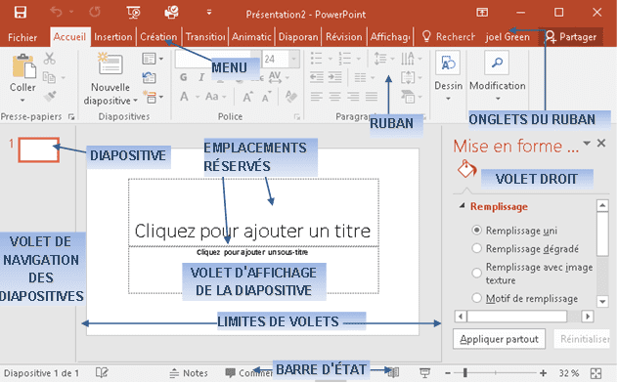 The software's versatility is not limited to business settings. Educators utilize PowerPoint to create engaging and informative presentations for lectures and online courses, leveraging its visual aids to enhance the learning experience. Similarly, creative professionals in fields such as design and advertising harness PowerPoint's design options to craft visually stunning pitch decks and promotional materials. PowerPoint's adaptability is further highlighted by its compatibility with other Microsoft Office tools, such as Word and Excel. Users can seamlessly integrate content from these applications into their presentations, ensuring a cohesive and comprehensive delivery of information.

# Latex:

 LaTeX, conceived by Leslie Lamport in 1985, is a document preparation system renowned for its unparalleled ability to generate high-quality typesetting for documents. At its core, LaTeX employs a markup language as its source code, empowering users to create and manipulate sophisticated document layouts. This robust system offers an extensive array of tools and features, elevating its utility for diverse applications. Users can seamlessly incorporate footnotes, bibliographies, and cross-references, ensuring comprehensive and well-structured documentation. LaTeX's prowess extends to the inclusion of mathematical formulas and graphs, providing an invaluable resource for professionals in fields such as mathematics, physics, and computer science.While LaTeX may not have undergone the same level of widespread development as Microsoft Office, its enduring importance persists, especially in disciplines where precision and typesetting quality are paramount. In the academic and scientific communities, LaTeX remains a stalwart tool, serving as the preferred choice for crafting research papers and scholarly documents. Its meticulous attention to detail, coupled with the ability to effortlessly handle complex mathematical expressions and symbols, distinguishes LaTeX as an indispensable asset for those seeking to convey information with the utmost clarity and precision. As a testament to its longevity and reliability, LaTeX continues to be embraced by professionals who prioritize the aesthetic and scholarly integrity of their documents.

**Some basic tools:**

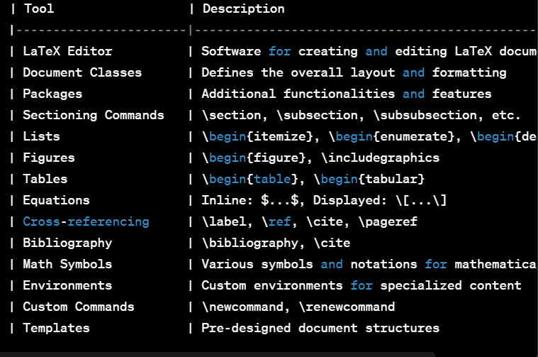

# HTML:

HTML, standing for HyperText Markup Language, is a pivotal and standardized markup language that plays a crucial role in the creation and structuring of content on the vast landscape of the World Wide Web. Its origins trace back to 1989 when visionaries Tim Berners-Lee and Robert Cailliau, working at CERN in Switzerland, conceptualized and developed this foundational language. Since its inception, HTML has metamorphosed into an indispensable tool for web development, providing a rich set of tools and features essential for crafting engaging and interactive digital experiences.

In the contemporary work landscape, HTML remains the linchpin of web development, utilized by professionals to create and structure not only static web pages but also dynamic, data-driven web applications. The versatility of HTML extends beyond its foundational role, encompassing diverse content types found on the web, from traditional articles and blogs to intricate multimedia presentations. As the internet continues to evolve, HTML's adaptability and continued development ensure its enduring relevance as an indispensable tool for web developers worldwide, contributing to the ever-expanding digital frontier.

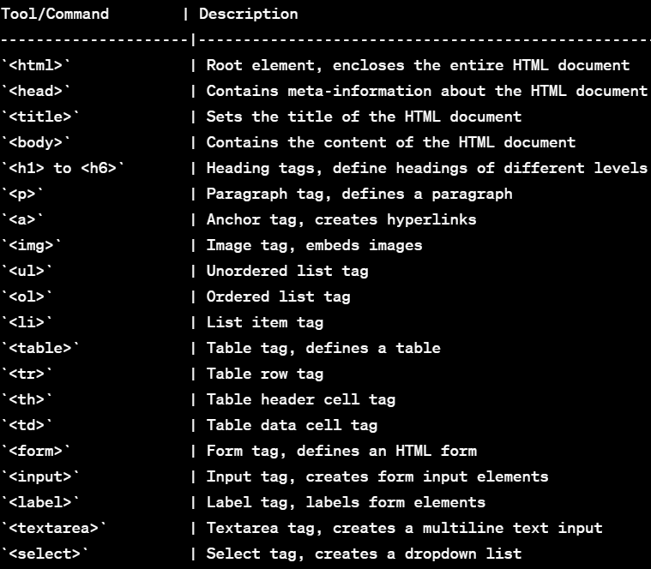 **Some important tools :**

# CSS:

Cascading Style Sheets (CSS) stands as a cornerstone in the realm of web development, offering a style sheet language designed to imbue web pages created with HTML with a rich array of styles and formatting. Conceived in 1996 by Håkon Wium Lie and Bert Bos during their tenure at CERN, CSS has become an indispensable tool for web developers seeking to customize and enhance the overall appearance of their creations. The multifaceted toolkit that CSS provides empowers developers to manipulate various design elements, including layout, typography, colors, spacing, and more, thereby facilitating the creation of visually captivating and user-friendly web pages and applications.

CSS operates by specifying styles for HTML elements, establishing a separation between content and presentation, thereby promoting clarity and flexibility in web design. The language leverages selectors, properties, and values to define how specific elements should be displayed on a webpage. Selectors target HTML elements, while properties dictate the stylistic attributes, such as font size, color, and margin, and values specify the desired characteristics for those properties.

The evolution of CSS has been marked by significant milestones, with each new version introducing enhancements aimed at simplifying web development and meeting the evolving expectations of users and designers alike. From the introduction of CSS1 to the latest advancements in CSS3, the language has expanded its capabilities, allowing developers to achieve intricate and sophisticated designs without sacrificing efficiency.

In the contemporary web development landscape, CSS plays a pivotal role in creating not only aesthetically pleasing but also responsive and accessible designs. Media queries, a feature introduced in CSS3, enable developers to apply styles based on the characteristics of the device or viewport, ensuring a seamless experience across a variety of screen sizes and devices.

 The role of CSS in web development cannot be overstated; it is a linchpin that enables developers to go beyond the structural foundations laid by HTML and craft immersive digital experiences. Its continuous evolution and adaptability underscore its significance, making CSS an indispensable and transformative tool that shapes the visual landscape of the internet. As web technologies continue to advance, CSS remains at the forefront, playing a pivotal role in defining the aesthetics and user experience of the digital realm.

# Git and Github:

## **What Are Git and Github?**

Git was developed in 2005 by Linus Torvalds as open source software for tracking changes in a distributed version control system.

Git is open source because its source code is made freely available for anyone to modify and use, aside from its creator. Open-source projects are built and maintained collectively by different developers in different locations. Git track changes via a distributed version control system. This means that Git can track the state of different versions of your projects while you're developing them. It is distributed because you can access your code files from another computer – and so can other developers. When you're building an open source project, you'll need a way to document or track your code. This helps make your work organized, and lets you keep track of the changes you've made. This is what Git lets you do. But you also need a place to host your code – which makes controlling each version of your project easier and faster. This is where GitHub comes in.

GitHub is a "hub" (a place or platform) where Git users build software together. GitHub is also an hosting provider and version control platform you can use to collaborate on open source projects and share files. When you're using GitHub, you're working with Git beneath the hood.

## Why Should You Learn Git and GitHub?

According to Techmonitor.ai, over 73 million developers use GitHub as of November 2021. And the GitHub community is set to hit 100 million users by 2025.

As you can see, millions of people all over the world use these tools, and the numbers just keep going up. Because of this, more companies are requiring new hires to know how to use Git and GitHub. So if you're looking for a developer job, these are essential skills to have.

If you're not using Git and GitHub, it's clear – you should be!

## What Is The Difference Between Git and Github?

Git is a version control system that manages and keeps track of your code. GitHub, on the other hand, is a service that let you host, share, and manage your code files on the internet. GitHub uses Git underneath, and lets you manage your Git repositories or folders easily on its platform.

So Git is the actual version control system and GitHub is the platform where you host your code.

## Common Git Commands To Know:

-git init  | lets you initialize Git in your folder.

-git add [Readme.md](https://readme.md/)  | lets you add the Readme file, while git add . lets you add all files in the present folder.

-git commit  | stores the added files. Use -m for message followed by the actual -message.

-git branch  | creates a new branch which is a new version of the repository as it appears when added, and -M to move the name to main.

-git remote | add origin finally connects the local folder to the repository on GitHub. It is followed by the repository's link.

-git push -u origin main  | pushes the code to GitHub. The -u flag creates a tracking reference for the branch, and origin main puts the code in the main branch.

-Those are some of the main commands you'll use all the time. This is a beginner and non-technical guide to help you get started using Git and GitHub, so we won't go into too much more detail here.

## How GitHub Revolutionized Software Collaboration

The significance of GitHub within the software development ecosystem cannot be overstated. It has democratized access to cutting-edge tools and technologies, empowering developers of varying expertise to contribute to and glean insights from an extensive repository of open-source projects. GitHub's collaborative nature transcends geographical barriers, enabling teams dispersed across the world to seamlessly collaborate. It stands as a linchpin for open-source initiatives, fostering innovation through the collective intelligence of a diverse global developer community.

Beyond its role in collaboration, GitHub serves as a vital instrument for version control, streamlining the tracking and management of code changes. This systematic approach to development minimizes errors and augments overall project stability. GitHub's suite of features, including issue tracking, pull requests, and discussion forums, creates a comprehensive project management environment, promoting effective communication among team members.

 GitHub's impact extends far beyond revolutionizing code hosting and sharing; it has fundamentally reshaped the culture of software development. Its inception marked a pivotal moment in the industry, and its continuous evolution has firmly entrenched its position as an indispensable tool for developers worldwide.

# Google services:

Established in 1998 by Larry Page and Sergey Brin, Google has grown into a worldwide technology powerhouse, transforming how individuals access information and engage with the digital landscape. Originating as a modest search engine, Google has evolved to offer a diverse set of tools integral to our daily routines. This essay will explore the inception, development, significance, and the defining tools that shape Google's extensive service ecosystem.

Founded by Larry Page and Sergey Brin in 1998, Google has transformed into a global technology powerhouse, reshaping how people access information and engage with the digital realm. Initially a search engine, Google has expanded its services significantly.

-**Some Google Services:**

** *-*Search Engine (Google Search):** Google's success originated from its groundbreaking search engine, driven by the PageRank algorithm and an intuitive interface, solidifying its global preference.

 ***-*Advertising Platform (Google Ads)**: Introduced in 2000, Google Ads empowered businesses to target audiences through online advertising, revolutionizing digital marketing and providing a cost-effective promotional channel.

 ***-*Email Service (Gmail):** Launched in 2004, Gmail offered a free, innovative email service with ample storage, threaded conversations, and powerful search capabilities, challenging established providers.

 ***-*Productivity Suite (Google Workspace):** Formerly G Suite (2006), Google Workspace encompasses tools like Docs, Sheets, Slides, and Drive, revolutionizing collaboration and document management in the cloud.

***-*Mobile Operating System (Android):** Google's acquisition of Android Inc. in 2005 paved the way for the Android operating system, now globally prevalent in smartphones and diverse devices.

Google services are integral to the contemporary digital landscape, underscoring their crucial role in our daily lives. The widespread use of Google Search ensures instant and comprehensive information access, fundamentally shaping our knowledge-seeking behaviors. Gmail has set new standards for communication, offering an efficient and feature-rich email experience. Google Workspace facilitates seamless collaboration, reshaping teamwork dynamics through tools like Docs, Sheets, Slides, and Drive. Google Ads has emerged as an essential platform for businesses, transforming digital marketing and providing a cost-effective way to reach target audiences. As the leading mobile operating system, Android not only powers the majority of smartphones but also exerts influence over the entire mobile ecosystem. Cumulatively, these services contribute to Google's overarching impact, shaping how we communicate, work, and navigate the digital realm.

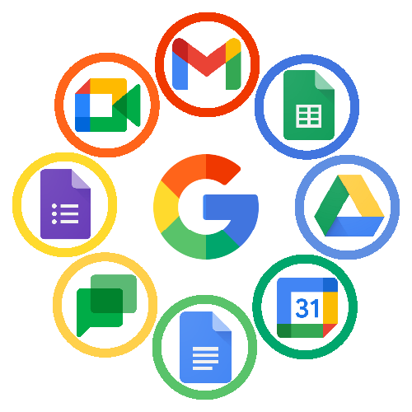

# Conclusion:

Microsoft Office is an essential tool that has revolutionized the way individuals, businesses, and organizations operate. The tools of Microsoft Office, including Word, Excel, PowerPoint, LaTeX, HTML, and CSS, have had a tremendous impact on the work environment by enabling efficient and faster communication, collaboration, data organization, and management. These tools have become an everyday part of life, with people using them to accomplish tasks such as document creation, financial analysis, project management, and presentations. Additionally, these tools have become critical for students and professionals alike, as they help in creating high-quality reports, presentations, documents, and analysis, amongst other things, making them indispensable in the modern age.

In conclusion, Microsoft Office tools have impacted the work environment positively by enabling individuals to create and manage documents, spreadsheets, and presentations more efficiently. Each tool in the suite, including Microsoft Word, Microsoft Excel, Microsoft PowerPoint, LaTeX, HTML, and CSS, has unique features that have evolved over the years, making them invaluable. These tools are not only important in the workplace but also in everyday life for creating documents, analyzing data, making presentations, and more. Furthermore, students and professionals rely on these tools to complete various tasks, making Microsoft Office an essential component of modern life.